Assignment(Introduction to Web Development)

Questions :
1. Explain the difference between frontend, backend, and full-stack development with
suitable real-world examples.
2. Create a simple diagram showing how the client-server model works in web architecture.
3. Describe how a browser requests and displays a web page from a web server.
4. Identify and list the tools required to set up a web development environment. Explain the
purpose of each.
5. Explain what a web server is and give examples of commonly used servers.
6. Define the roles of a frontend developer, backend developer, and database administrator
in a project.
7. Install VS Code and configure it for HTML, CSS, and JavaScript development. Take a
screenshot of the setup.
8. Explain the difference between static and dynamic websites. Provide an example of
each.
9. Research and list five web browsers. Explain how rendering engines differ between
them.
10. Draw a labeled diagram showing the basic web architecture flow — client, server,
database, and APIs.

Solutions :
1.
*Frontend: The Dining Room
The frontend is everything you see and interact with.
- The Analogy: The decor, tables, and physical menu.
- Netflix Example: The movie posters, search bar, and play button.
- Tech: HTML, CSS, JavaScript.
*Backend: The Kitchen
The backend is the behind-the-scenes logic and storage.
- The Analogy: The chefs, the pantry, and the recipes.
- Netflix Example: The algorithm suggesting shows and the servers streaming the video.
- Tech: Python, Node.js, Databases.
*Full-Stack: The Manager
Full-stack means handling both frontend and backend.
- The Analogy: A manager who designs menus and cooks food.
- Netflix Example: Building a new feature solo, from the button to the database.

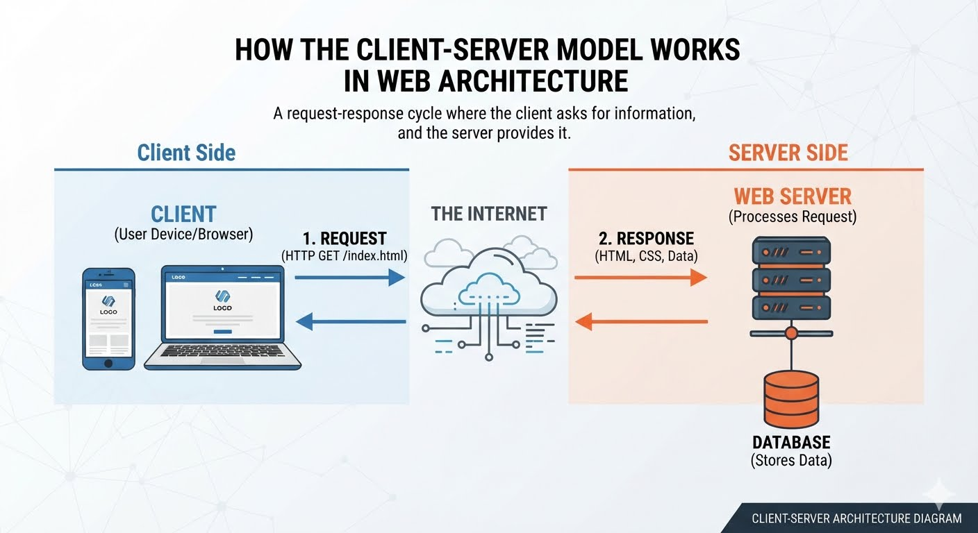
2. Required image :
3. Here is how a browser requests and displays a webpage, using the layout from the diagram:
1. The Request (Client Side)
- DNS Lookup: You type a URL (like google.com). Your browser contacts a Domain Name System (DNS) server to find the server's real IP address (like 142.250.190.46).
- HTTP Request: The browser sends a request packet across The Internet asking for the website files.
2. The Response (Server Side)
- Processing: The Web Server receives the request and fetches the required files (HTML, CSS, JavaScript, and images) from its storage or Database.
- Delivery: The server sends these files back to your browser over the internet as a response.
3. The Rendering (Back to Client)
- Parsing: Your browser reads the HTML to build the page structure and the CSS to style it.
- Execution: The browser runs any JavaScript code to make the page interactive (like animations or login popups), showing you the final webpage.

4. To set up a modern web development environment, you only need four essential categories of tools. Here is how they break down:
1. Code Editor (IDE)
- Purpose: The software where you write, edit, and organize your code.
- Top Tools: Visual Studio Code (VS Code), Cursor, WebStorm.
- Why it matters: It provides syntax highlighting (color-coding text), auto-completes code, and highlights errors as you type.
2. Web Browser & DevTools
- Purpose: To view, test, and debug your websites locally.
- Top Tools: Google Chrome, Mozilla Firefox, Brave.
- Why it matters: Built-in "Developer Tools" (accessible by pressing F12) let you inspect HTML/CSS live, test responsiveness on mobile screens, and track network requests.
3. Runtime Environment & Package Manager
- Purpose: Allows you to run server-side code on your computer and install external code libraries.
- Top Tools: Node.js (Runtime) with npm or pnpm (Package Managers).
- Why it matters: You need this to download pre-built code packages (like React or Tailwind CSS) and to run local development servers.
4. Version Control System (VCS)
- Purpose: Tracks changes in your code and allows you to collaborate with others.
- Top Tools: Git (the local system) and GitHub or GitLab (the cloud hosting platforms).
- Why it matters: It acts as a safety net, letting you revert to previous working versions of your project if your code breaks.
5. A web server is a computer (hardware) running specialized software that stores website files (HTML, CSS, JavaScript, images) and delivers them to users over the internet when requested.
Think of it as a digital librarian: when a user asks for a book (webpage), the librarian finds it in the stacks and hands it to them.
Popular Web Server Software
- Nginx: A high-performance server known for its speed and efficiency. It handles massive amounts of traffic easily and is often used to distribute user requests evenly across multiple backend systems (load balancing).
- Apache HTTP Server: One of the oldest and most reliable web servers. It is highly customizable through modular plug-ins and powers a massive portion of the traditional web.
- Microsoft IIS (Internet Information Services): A secure server built specifically for Windows ecosystems. It is typically used by businesses running applications built with Microsoft technologies like .NET.
- LiteSpeed: A newer, commercial web server designed to drop directly into Apache setups. It focuses on extreme speed, built-in caching, and boosting performance for platforms like WordPress.

6. In a software project, these three roles work together like a crew building a house: the frontend developer designs the interior, the backend developer builds the plumbing and wiring, and the database administrator secures the vault.
1. Frontend Developer (The Client Side)
- The Role: Builds everything the user sees, clicks, and interacts with directly on their screen.
- Key Tasks: Translates design mockups into working code, ensures the layout looks perfect on both mobile phones and desktops, and optimizes page loading speeds.
2. Backend Developer (The Server Side)
- The Role: Builds the hidden logic, APIs, and servers that power the application from behind the scenes.
- Key Tasks: Writes user authentication logic (like logins), handles payment processing connections, and processes requests sent from the frontend to fetch the right information.
3. Database Administrator / DBA (The Data Layer)
- The Role: Designs, secures, and maintains the databases where all the application's permanent data is stored.
- Key Tasks: Optimizes data storage for fast search results, manages daily backups to prevent data loss, and sets up strict security permissions to protect sensitive user information.

7. Required screenshots :
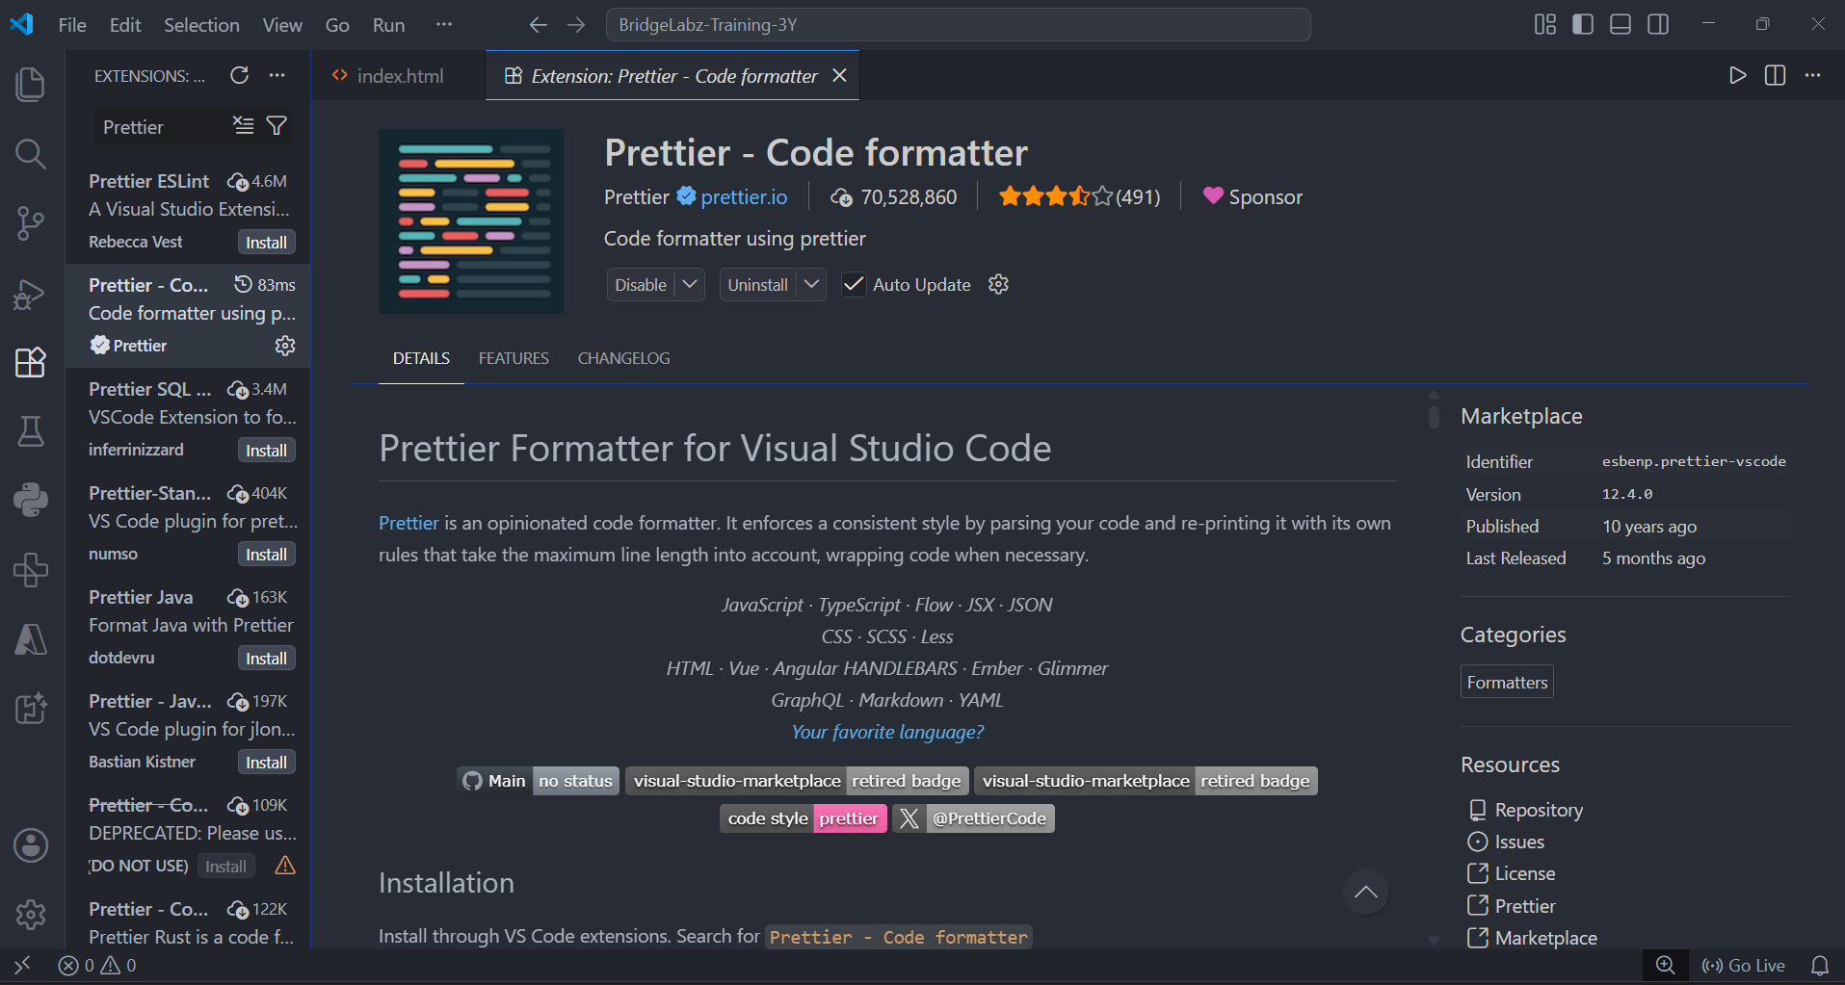

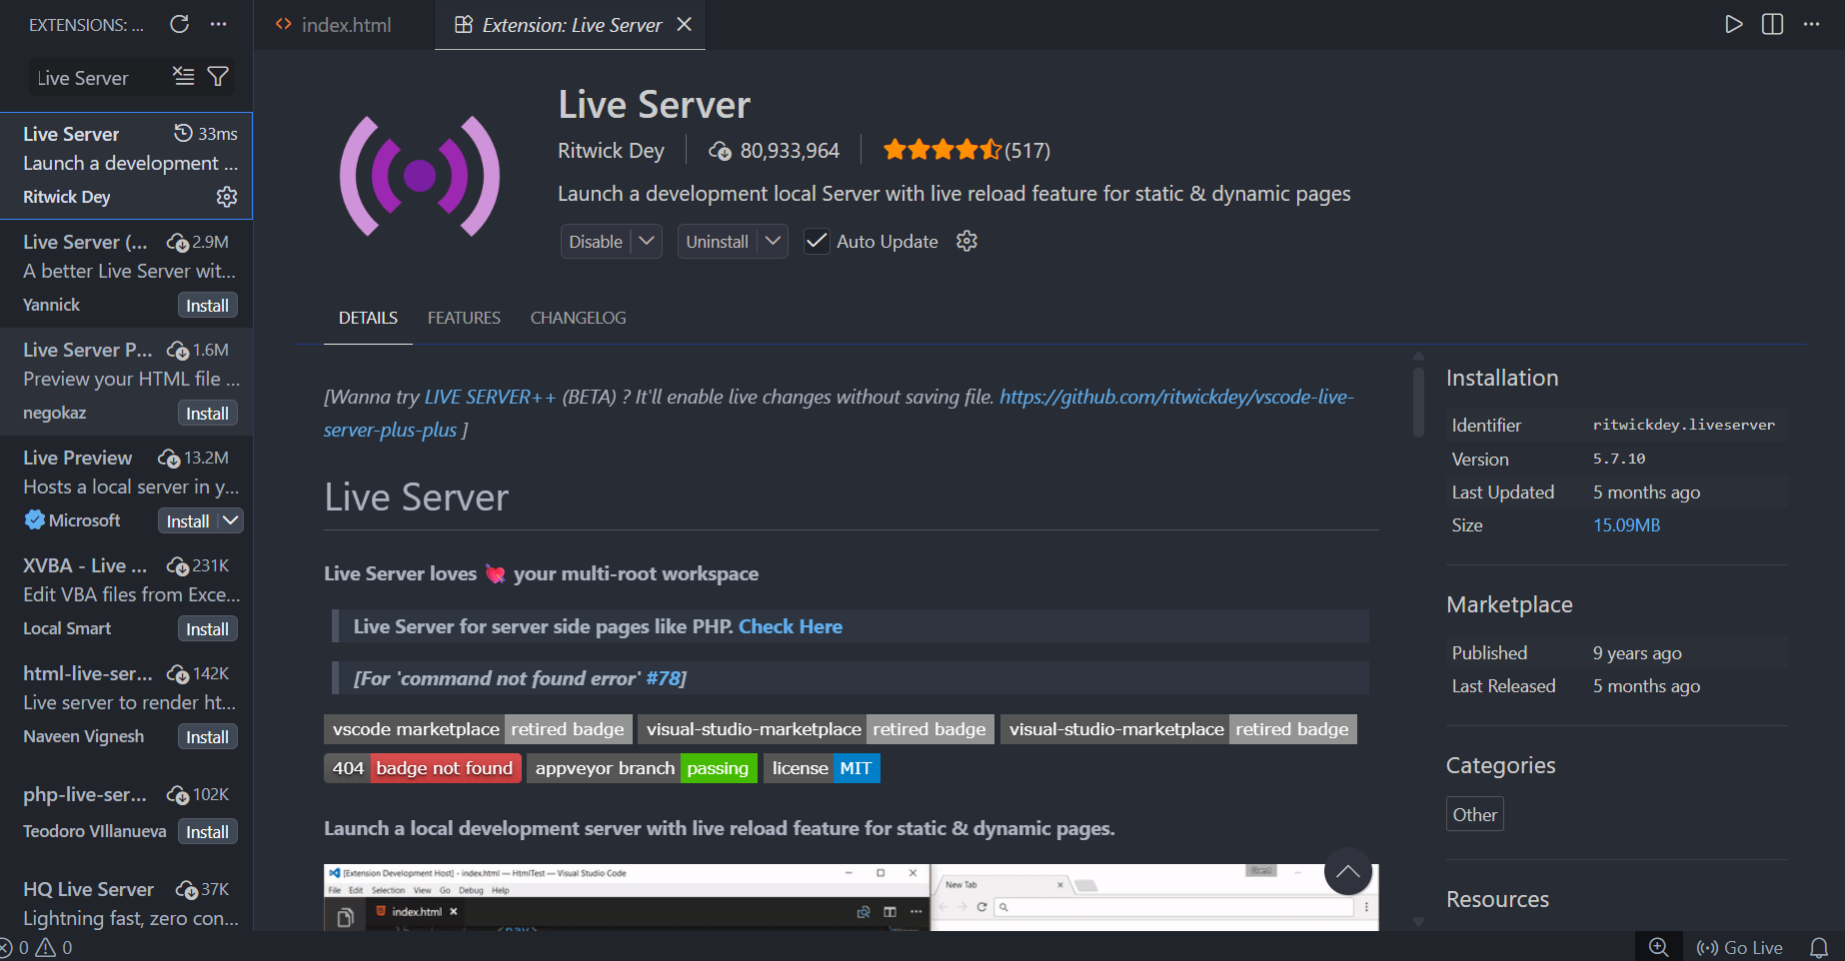

8. The main difference between static and dynamic websites is how the content is delivered to the user: static websites show the exact same content to everyone, while dynamic websites change content based on user interaction, time, or location.
Static Websites (The Digital Brochure)
Static websites consist of pre-written HTML, CSS, and JavaScript files stored on a server. When a user visits the site, the server simply hands over these exact files. The content only changes if a developer manually edits the code.
- Key Features: Extremely fast to load, cheap to host, and highly secure since there is no backend database to hack.
- Real-World Example: A local restaurant's landing page that displays their fixed menu, address, and hours of operation. Everyone who visits sees the identical page.
Dynamic Websites (The Live Application)
Dynamic websites generate pages on the fly using a backend server and a database. When a user requests a page, the server pulls custom data from the database, builds a unique HTML page for that specific user, and then sends it to their browser.
- Key Features: Highly interactive, personalized to individual accounts, but requires more server power and ongoing maintenance.
- Real-World Example: Amazon or Netflix. When you log in, the products, movie recommendations, and dashboard layout are uniquely generated just for you. A different user logging in at the exact same time sees an entirely different page.
9. 5 Major Web Browsers and Their Rendering Engines
A rendering engine is the core software component inside a browser that translates code (HTML, CSS, JavaScript) into the visual webpage you see on your screen. [1, 2]
Here are five prominent browsers and how their engines differ:
- Google Chrome: Uses the Blink engine. It focuses on fast processing speeds, modern web standards, and high performance by processing multiple tabs independently.
- Mozilla Firefox: Uses the Gecko engine. It prioritizes open-source standards compliance, security, and rendering layouts accurately without being tied to Google's system architecture.
- Apple Safari: Uses the WebKit engine. It is highly optimized for energy efficiency, smooth scrolling, and strict battery-saving metrics across Apple hardware devices.
- Microsoft Edge: Uses the Blink engine. It matches Google Chrome's underlying engine for flawless website compatibility but adds unique memory-saving optimizations built for the Windows ecosystem.
- Brave: Uses the Blink engine. It shares the core engine of Chrome for reliable website rendering but strips out tracking code to focus strictly on privacy, ad-blocking, and data protection.

10. Required diagram :
